**Experiment No : 01**

***Title :  Application of at least two traditional process models.***

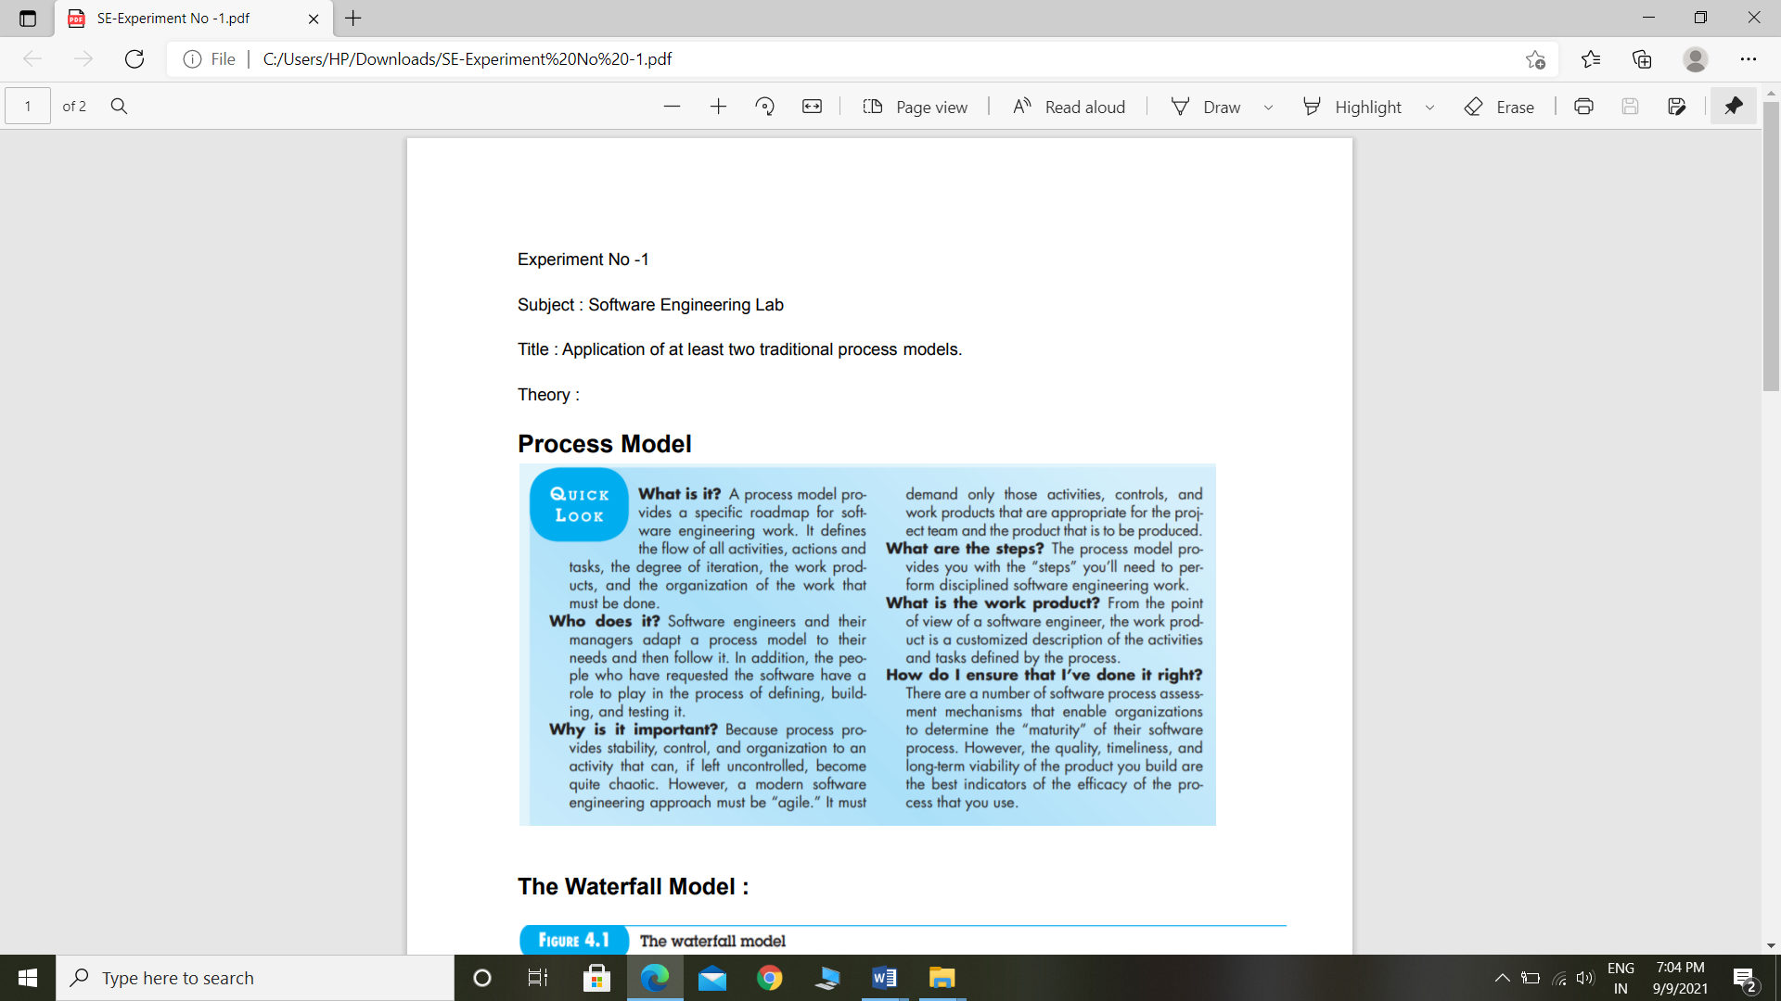

**Waterfall Model**

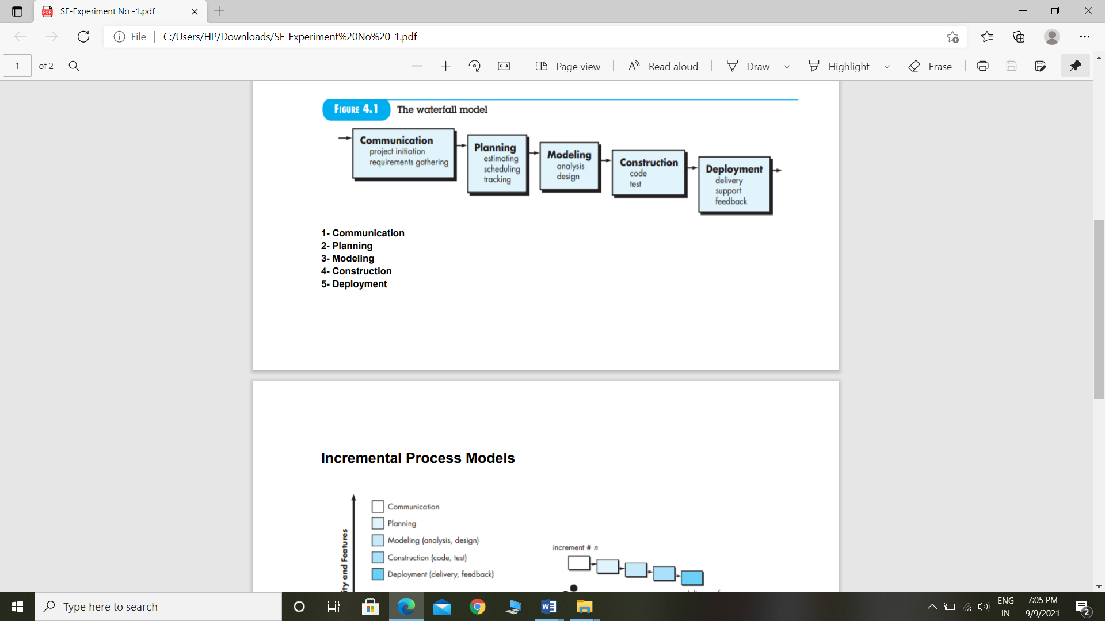

* **Communication:-**

The Weather Application project give you the correct weather information like temperature, humidity, wind speed, cloud situation. For knowing weather condition we requires this type of websites.

* **Planning**:

In this project we are going to do weather information of any location. For that we are going to do following things :

* Web-based Weather Application Using OpenWeatherApi.
* Make your account inOpenWeatherMap for accessing their API for our project. Create an Account. It’s totally FREE. After making an account you will get a default key just note/copy that key because we will use in javascript code.

* **Modelling:-**

In Weather Application project we design homepage with UI. It will be contain an images in background and one search bar using react icons for searching any location. Then it will show the current information of weather.

* **Construction:**

In this weather application project we are going to do following things:

* Step 1 : Create html page and add icons using react icons in it.
* Step 2 : Give style to Html page with CSS properties.
* Step 3 : flexbox to create a responsive, centered card, how to access APIs using JavaScript's 'fetch()', and how to dynamically modify content on the page and background images.
* Step 4 : Display results.
* **Deployment:**

Under the product deployment phase, the project team implements the programming and coding to each system location.

Through this project the user can view weather information like temperature, wind speed, humidity, cloud situation.

**Incremental Model**

**Displaying Result**

**Fetch weather**

**Getting start with the API**

**Function and features**

**Project Calendar Time**

**Creating CSS styles**

**Creating the HTML markup**

**Information about project**